Product category: SWITCHGEARS

1. RPM METER

Company name: SELEC

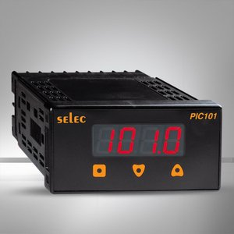

1. AMPERE METER

COMPANY NAME: SELEC

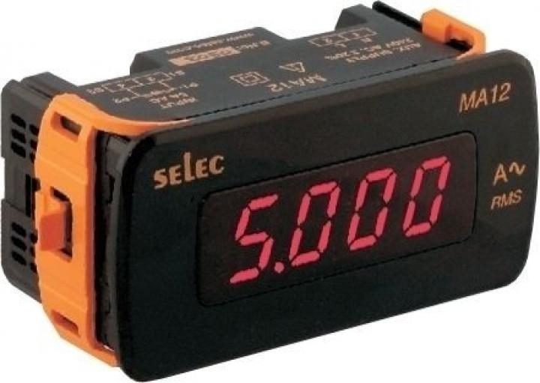

1. VOLTMETER

COMPANY NAME: SELEC

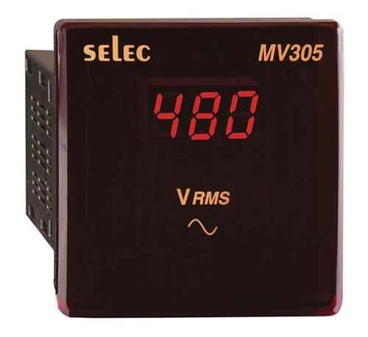

1. VOLT-AMP-FREQ METER

COMPANY NAME: SELEC

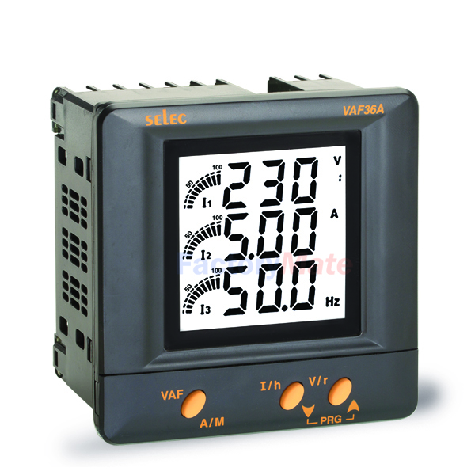

1. PID CONTROLLER

COMPANY NAME: SELEC

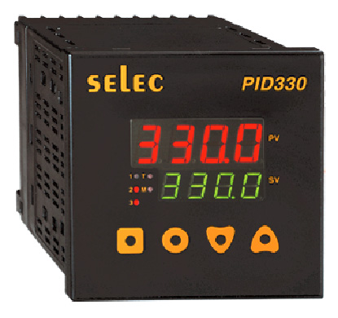

1. COUNTER METER

COMPANY NAME : SELEC

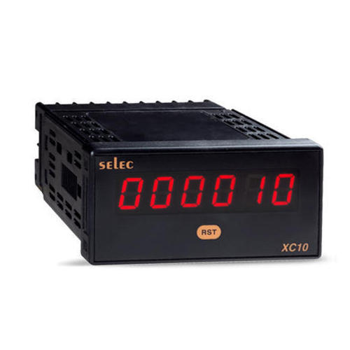

1. TIMERS

COMPANY NAME: SELEC

